|  |  |  |  |  |  |  |  |  |  |  |  |  |  |  |  |  |  |  |  |  |  |  |  |  |  |  |  |  |  |  |
| --- | --- | --- | --- | --- | --- | --- | --- | --- | --- | --- | --- | --- | --- | --- | --- | --- | --- | --- | --- | --- | --- | --- | --- | --- | --- | --- | --- | --- | --- | --- |
| |  |  |  |  |  |  | | --- | --- | --- | --- | --- | --- | | **Test during week beginning**  **11.09.23** | **Test during week beginning**  **18.09.23** | **Test during week beginning**  **25.09.23** | **Test during week beginning**  **2.10.23** | **Test during week beginning**  **9.10.23** | **Test during week beginning**  **16.10.23** | | **Words with ‘au’ spelling** | **Words the prefix ‘in’** | **Words with the prefix ‘im’** | **Words with prefix ‘il’ or ‘ir’** | **Homophones & near homophones** | **Homophones & near homophones** | | caught  naughty  taught  daughter  autumn  clause  astronaut  applaud  author | Inactive  incorrect  inaccurate  insecure  indefinite incomplete  infinite  inedible  inability  indecisive | information  adoration  sensation  preparation  education  location  exaggeration  concentration  imagination  organisation | creation  radiation  indication  ventilation  relegation  dedication  demonstration  abbreviation  translation  vibration | immature  immeasurable impossible  immortal  imperfect  impatient  immovable  impolite  important  improper | illegal  illegible  illogical  illiterate  illicit  irregular  irrelevant  irresponsible  irrational  irresistible | | **Topic words (Geography)** | **Topic words**  **(History)** | **Topic words**  **(P.S.H.E)** | **Topic words**  **(Science)** | **Topic words**  **(Maths)** | **Topic words**  **(Computing)** | | exchange  globalisation  international  local  products | caliph  caliphate  Arabia  Mecca  Muhammad | environment  compassion  money  responsibility  entertain | habitat  amphibian  mammal  insect  life process | calculate  addition  subtraction  multiplication  division | algorithm  repeats  pixels  graphics  digital footprint | |

**Please revise these words over the half term.**

**Colvestone Primary School   
Year 4 spelling plan – Autumn 1**

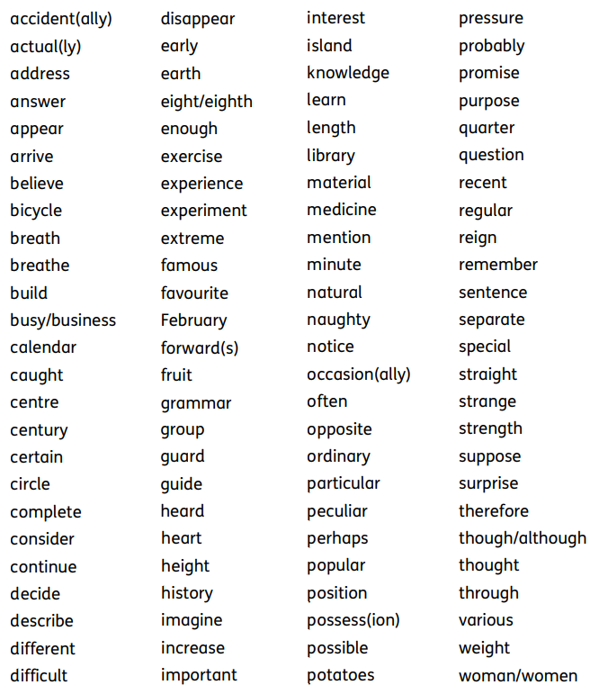

**Year 4**

Here are some common exception words (words that are spelled without using the normal spelling rules) that children are expected to be able to spell by the end of Year 4 (age 9).